RESOLUTION NO.__________

RE: CERTIFICATE OF APPROPRIATENESS UNDER THE
PROVISIONS OF THE ACT OF THE PENNSYLVANIA
LEGISLATURE 1961, JUNE 13, P.L. 282 (53
SECTION 8004) AND BETHLEHEM ORDINANCE NO.
3952 AS AMENDED.

WHEREAS, it is proposed to install new signs at 15 E Third Street.

NOW, THEREFORE, BE IT RESOLVED by the Council of the City of Bethlehem that a Certificate of Appropriateness is hereby granted for the work.

Sponsored by: (s)

(s)

ADOPTED BY COUNCIL THIS DAY OF

(s)
President of Council

ATTEST:

(s)
City Clerk

HISTORIC CONSERVATION COMMISSION

CASE # 577– It is proposed to install new signs at 15 E Third Street
OWNER/APPLICANT: Jessica Kroope / Signarama-Lehigh Valley

The Commission upon motion by Mr. Cornish seconded by Mr. Traupman adopted the proposal that City Council issue a Certificate of Appropriateness for the proposed work described herein:
- The proposal to install a new sign at 15 E Third Street was represented by Steve Stigliano from Signarama.
- The sign will be 24”w x 120”w and read “H2O Hookah Lounge” in white lettering on a blue background.
- The sign will be fabricated of 1/2” MDO plywood instead of the proposed metal. The sign will have square corners as proposed.
- A ½” white border pinstripe approximately 1” to 1-1/2” from the edge will be added to the perimeter of the sign.
- The sign will align with the new sign on 13 E. Third St.
- An updated drawing of the signs must be submitted to show the requested modifications for approval by the HCC Chairman or Historic Consultant.
- The proposed motion was unanimously approved.

CU: cu
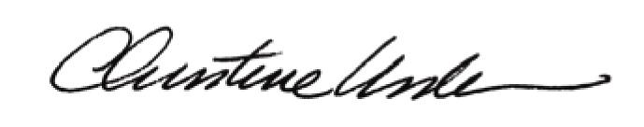

By:

Date of Meeting: January 25, 2016 Title: Historic Officer

